**Numerical Investigation of the Effect of Operating Parameters on a planar Solid Oxide Fuel Cell**

Abhishek Raj, Agus P. Sasmito, Tariq Shamim

Institute Center for Energy (iEnergy), Department of Mechanical and Materials Engineering Masdar Institute of Science and Technology,

P.O. Box 54224, Abu Dhabi, UAE

*Full Length Article*

Corresponding Author

Tariq Shamim

Professor of Mechanical Engineering

Masdar Institute of Science & Technology

Abu Dhabi, UAE

Phone: +971 (2) 810-9158

Fax : +971 (2) 810-9901

E-mail: tshamim@masdar.ac.ae

**Numerical Investigation of the Effect of Operating Parameters on a planar Solid Oxide Fuel Cell**

Abhishek Raja, Agus P. Sasmitoa,b, Tariq Shamima*

aInstitute Center for Energy (iEnergy), Department of Mechanical and Materials Engineering, Masdar Institute of Science and Technology, Masdar City, Abu Dhabi, United Arab Emirates

bDepartment of Mining and Materials Engineering, McGill University, Montreal, QC, Canada

*Corresponding author. Email: [tshamim@masdar.ac.ae](mailto:tshamim@masdar.ac.ae)

# Abstract

The three operating parameters – temperature, stoichiometry and the degree of humidification – constitute key factors required to ensure high performance of the solid oxide fuel cell (SOFC). A careful trade-off between performance and parasitic loads is required in order to optimize the output. The present study numerically analyzes the influence of the key operating parameters on the performance of planar type of SOFC and parasitic loads utilizing a validated three dimensional mathematical model which takes into account of the conservation of mass, momentum, species and charge. The numerical results indicate that the cell performance is enhanced at high temperature and cathode stoichiometry and it declines with increasing cathode relative humidity. Furthermore, cathode stoichiometry is found to have higher influence on the cell performance as compared to the anode stoichiometry. The gain in cell performance however, has to be balanced with the changing parasitic load requirement from pumping, humidification and heating. The results presented herein can assist in the selection of optimum or near-to-optimum operating parameters for high performance planar type SOFC.

**Keywords:** Solid oxide fuel cell, operating parameters, parasitic load, cathode relative humidity, stoichiometry

# Nomenclature

*Abbreviation*

CHP Combined heat and power

GDL Gas diffusion layer

SOFC/s Solid Oxide Fuel Cell/s

1D/2D/3D One/two/three dimensional

*Symbols*

*C* Concentration (mol/m3)

*Cp* Specific heat at constant pressure (kJ/(kg K))

 Binary diffusivity coefficient of species *i* in species *j* (m2/s)

 Cell voltage (V)

 Equilibrium state potential (V)

*f* Body force (N)

 Faraday’s constant (C)

*hvap* Enthalpy of vaporization (kJ/kg)

 Current in the electrolytic medium (A)

 Current in the electrode medium (A)

 Current density at anode / cathode (A/m2)

 Mass flow rate of species *i* at inlet/outlet

 Molecular mass of species i (kg)

*p* Pressure (Pa)

*P*2 Pressure at stack exhaust (Pa)

 Gross power output (W)

 Power consumed in process *i*

 Net Power (W)

 Power consumed for parasitic loads (W)

*pref*Pressure at reference point

Δ*p* Pressure drop (Pa)

 Charge source/sink (C/sec or A) at region *i*

 Mass flux (kg/(m2s))

 Source/sink term for the species

 Temperature (K)

 Reference Temperature (K)

 Velocity (m/s)

 Mass fraction of species *i*

*x* Mole fraction

 Transfer coefficient at electrode

*β* Coefficient for channel geometry

*γ* Heat Capacity Ratio

 Porosity

*ηk* Efficiency of the k component

 Permeability of medium (m2)

 Dynamic Viscosity of medium (Pa.s)

 Density (kg/m3)

 Conductivity (S/m)

 Potential (V)

1. Introduction

Fuel cell is an energy conversion system which converts chemical energy directly into electrical energy without any adverse effect on the environment. Since the conversion from chemical to electrical energy is direct, less energy losses are incurred during transformation. A popular derivative of this technology is the solid oxide fuel cell (SOFC), which utilizes ceramic material as electrolyte. This technology is gradually establishing itself to be a promising substitute for conventional power sources as a flexible, silent and emission free power source for stationary as well as for automotive applications. The SOFC can be used both as a ‘stand-alone’ power source as well as can be coupled with the existing conventional energy systems so as to meet the demand during the peak load period [1]. Among the various existing fuel cell variants, the SOFC is of considerable interest due to its capability of rendering high rates of power production at comparatively lower energy requirements [2]. Majority of the studies on SOFCs have remained focused on exploring the design aspect especially in terms of the impact of electrolyte materials [3], configuration (planar, tubular etc.) [4] and integration strategies [5]. Other studies have analysed the dynamic behavior [6], the effects of reforming higher hydrocarbons [7], and the impact of operating conditions through various 1D [8], 2D [9] and 3D [6,10,11] mathematical models. The impact of operating conditions such as fuel utilization, flow rate, temperature has been the focus of studies by Serincan *et al* [12] and Dokamaingam *et al* [13]. Serincan *et al* [12] emphasized the importance of applied load to the fuel input requirements and recommended lower fuel supply at moderate loads due to higher efficiencies and increased fuel supply at higher loads as a result of reduced efficiencies. Dokaimaingam *et al* [13] explored the impact of various operating parameters such as cell level humidification, temperature, pressure and load on the current density and efficiency in a methanol powered SOFC. Huang *et al* [14] analyzed the performance as well as syngas cogeneration at operating temperatures varying from 700˚C to 900˚C using a direct methane SOFC. They observed the increase of syngas production and the fuel cell performance at higher temperatures. The impact of cathode humidification on a single anode supported SOFC was studied by Nielsen *et al*. [15]. They found that humidification caused a fast transient change which resulted in a long term but reversible performance degradation.. Pfafferodt *et al* [16] developed a one dimensional steady state SOFC model to determine a suitable temperature range for the optimum performance. However, they did not explore the impact of other parameters. Ni *et al.* [17] developed a 2D model of a planar SOFC to investigate the effect of inlet gas composition, velocity, electrode permeability and porosity. The study did not include the effect of the parasitic losses as a result of the use of auxiliary devices. Huangfu *et al.* [18] used a one-dimensional model to develop a multiphysics SOFC model. They investigated the fuel cell performance at various temperature and humidity ranges. Their work indicated a critical role of transfer coefficient (αe) in the voltage output from a SOFC model.

In summary, the above mentioned works explored various dimensions of SOFC operation;however, none of these studies incorporated the parasitic loads in the evaluation of performance. The parasitic loads associated with fuel cell systems include the pumping power of the compressors required for supplying the fuel and air, the heating power for heaters to heat the reactants, the humidification power required for humidifying reactants and power required to pump coolant liquid. Incorporating the parasitic losses in the study of SOFCs will result in a better evaluation of the SOFC system in terms of net power output and auxiliary power required and will help derive accurate optimal operating conditions. Therefore, the aim of the current study presented here is to investigate the effect of operating conditions on the SOFC performance incorporating the influence of parasitic loads. This is achieved by developing a three dimensional SOFC model representative of the inherent physics using COMSOL software© and thereby analyzing it under various operating conditions. The operating conditions whose impact on the performance of the SOFC is explored include temperature, cathode relative humidity, and anode and cathode stoichiometry respectively.

1. Modeling

2.1 Geometry and Physics

In the present work, a three dimensional model, representing a small scale SOFC of the order of 1 kW is developed using the data from the literature [19]. The model incorporates the mass, momentum and charge balance, secondary current and Butler-Volmer equations within their planar and porous domains. Some of the assumptions employed in modeling are: (i) the gas mixture is treated as an ideal gas; (ii) the flow is laminar due to the low Reynolds number (iii) isothermal conditions; and; (iv) that the gas diffusion layer GDL is made of isotropic and homogeneous porous materials.

Figure 1 shows the computational domain of the model. The domain includes a section of the ceramic membrane ,both the electrodes and gas flow channels in a parallel configuration. The values of the geometrical and physical model parameters are listed in Table 1. The governing equations include the conservation of mass and momentum.

 (1)

 (2)

 (3)

Since the flow is laminar, the pressure drop is proportional to the gas velocity in the porous electrolyte layer and is modeled as

 (4)

The multispecies mass transport in the computational domain, which comprises of the gas channels and GDL, is described by the Maxwell–Stefan equation. The flux of each species is solved in terms of mass fraction. The general form of the Maxwell–Stefan equation is shown below.

 (5)

The electrochemical reaction is modeled by placing mass sources and sinks for the reactants and products, respectively in correspondence with the computed rates in the anode and cathode regions neighboring the electrolyte.

 (6)

 (7)

 (8)

Equation (6) and (7) yield the stoichiometric amounts of the hydrogen and oxygen. In practice, the amounts of hydrogen and oxygen fed to the fuel cell are in excess of their stoichiometric values as shown in Equations (9) and (10).

 (9)

 (10)

The model solves for oxygen and water concentrations while calculating the third species (nitrogen) through the mass balance equation given as follows

 (11)

Similarly on the anode side, hydrogen is solved while the mass fraction of water is calculated from

 (12)

The binary diffusivities *D*ij used in the Maxwell–Stefan equations were calculated from the following empirical correlation [20]

 (13)

The overpotentials at the catalyst layers on both the electrodes are governed by the electrode and electrolyte phase potentials (and) and the equilibrium state potential () and are given by:

 (14)

The current densities  and  are calculated through the oxygen and hydrogen concentrations (and) [20]

 (15)

 (16)

=  (17)

=  (18)

 (19)

In the above equations, the values of αa and αc for anode and cathode are taken from Ref. [19] and are listed in Table 1. The secondary current distribution incorporates the effects of electrode kinetics as well as that of the electrolyte resistance. In the electrodes and the electrolyte membrane, it is represented by the following relations:

 (20)

 (21)

 (22)

 (23)

Here, Equations (20) and (22) depict the relationship between the electrolytic current and membrane conductivity; and Equations (21) and (23) describe the dependencies of the electrode current.

The parasitic loads constitute the power consumption incurred in the auxiliary systems in order to maintain the reactant supply to the fuel cell at specified conditions. In the present work, the parasitic loads include the heater load, humidifier load and compressor load at anode and cathode. It should be mentioned here that an increase of the humidification at higher temperature reduces the SOFC performance as reported by Huangfu *et al.* [18] and Kim *et al.* [21]. However, we considered the humidifier load in the parasitic loads to quantify the net effect of external humidification and to emphasize the negative effect of humidification on the SOFC performance. The parasitic load also included a compressor, which is required to compensate for the pressure drop. The following relation from Ref. [22] is used to calculate the pressure drop:

 (24)

Here is the gauge pressure at stack exhaust,  is the STP pressure (1 atm) while is the air density at STP.  is the taken to be equal to in this case while the coefficient β which depends on the channel geometry is taken to be 1 due to parallel channel geometry.

Equations (25)-(27) are utilized for the calculations of the above mentioned loads.

 (25)

 (26)

 (27)

Using the constant efficiency approach over a range of operating conditions as used in Solehati et al.[23], all auxiliary appliances are supposed to be 80% efficient.

**2.2 Boundary Conditions**

The boundary conditions require the specification of the operating temperature, stoichiometry at the anode and cathode, and the cathode relative humidity. From these values, the inlet mass flow rates at the anode and cathode are calculated. Table 2 lists the values of these parameters used in the base case. However, the SOFC performance is also investigated at other conditions, which will be described later. The pressure at the outlet is set to the ambient conditions while the velocity is set up with no slip conditions and zero diffusive flux. The cell voltage is applied at the cathode while the anode is grounded. In order to analyze the performance, the power output is evaluated in terms of gross and net outputs generated which are related as shown in Equations (28)-(30):

 (28)

 (29)

 (30)

**2.3 Numerics**

The model is computed by using COMSOL Multiphysics© softwareby employing fully coupled solvers which solve the inherent physics simultaneously using the Newton-Raphson iterations. The model is simulated with meshes of various sizes to check for grid independence. The final mesh size is described in Table 3. The convergence criterion is taken to be 10-3.

1. Results and Discussion

The developed model as shown in Figure 1 was validated by simulating it under various operating conditions and comparing the results with experimental and modeling results available in literature. The model is simulated at a temperature of 700oC with remaining operating conditions being the same as in Table 2. The simulation’s voltage-current (V-I) characteristic is compared with the experimental results of Yamaji *et al* [24] and Patel *et al* [25].These papers have investigated the SOFC performance by utilizing NiO-scandia stabilized zirconia and NiO-yttrium stabilized zirconia respectively as the electrode materials which have properties similar to what has been used in the developed model. To add further credence to the model, we also compared the model simulation results at a temperature of 900oC with the works of Pfafferodt *et al* [16] and Chen et al [26]. Chen *et al* [26] carried out experimental analysis on the performance of SOFC with YSZ-LSM (yttria stabilized zirconia-Lanthanum strontium manganese substituted perovkite oxide) cathode and LSCM (Lanthanum strontium chromium manganese perovskites oxide) anode. It is important to note that the cathode properties of the developed model bear a closer relationship to YSZ-LSM as compared to that of the model anode properties and LSCM. Consequently, good agreement is observed between the results obtained at 700oC while there is relatively highera slight discrepancy in the results at 900oC. This disagreement is mainly due to the difference in properties as explained above or due to possible differences in the operating conditions since the information about the initial flow rates and the input channel dimensions used in [26] is not mentioned.

The present study investigates the effects of the temperature, cathode humidity, anodeand cathode stoichiometry on the planar SOFC operation. The analysis is carried out by varying each of the operating parameters while keeping the remaining conditions as same as that in the base case. Table 4 lists the various values of operating parameters that are used in the present study. Power output and the parasitic loads are calculated on the basis of per square meter active area of the fuel cell. The parasitic losses calculated in this paper through modeling are close to the experimental parasitic load results as cited by the report on System development for planar SOFC based power plant by Alstom Research and Technology [27]. It cites the combination of parasitic losses and heating losses (excluding hot standby losses) to constitute around 25% of the total power output at 0.7115 V while in the present case, it is 21.5% under the similar conditions.

**3.1 Effect of operating temperature**

Investigation into the effect of operating temperature on the performance and the parasitic load is undertaken and the results are analysed. Figure 3 depicts the V-I curve at operating temperatures ranging from 700oC to 1000oC. The figure highlights the strong positive influence which temperature exerts on the performance. The improved performance is particularly more substantial at higher loads. At a high load of 0.2 V, the current is found to increase almost three-fold as the operating temperature is varied from 700o C to 1000o C. This strong dependency of performance on the operating temperature is also ascertained in Figure 4 which demonstrates the gross and net power output at various operating temperatures. The net power output follows the same trend as the gross power output albeit at a lesser magnitude. The power output increases with the operating temperature and reaches a peak value at intermediate loading conditions (0.5V-0.4V). This is supported by similar findings by Ni *et al* [28].

The heater load is also found to increase with operating temperatures as well as load. For example, an increase of 44% in the heater work from 700o C to 1000o C at high loading conditions close to 0.3 V is observed. It assumes significance by reaching a maximum of around 17 % of the gross power output at the operating temperature of 1000o C at higher loading conditions (0.3V). .The heater load is 37% of the total parasitic losses at high loading condition (0.3V), however, under lower loads (0.9 V) at the same temperature, this share increases to 52% of the total parasitic load. The contribution of heater work to parasitic loads as well as its value as a percentage of the power output remains significant. The heater load may be reduced by utilizing the heat generated within the SOFC through possibly a recirculation system for combined heat and power (CHP) applications.

**3.2 Effect of Cathode Stoichiometry**

The influence of cathode stoichiometry on the performance and parasitic loads is investigated by varying it from 200% to 400%. Figure 5 shows the SOFC performance at three cathode stoichiometries in terms of V-I characteristic. The results show that the increase in cathode stoichiometry improves the performance, however, the effect is much less pronounced than that of the operating temperature. This improvement is more evident at higher loading conditions with the current density showing a 23% rise when the cathode stoichiometry is varied from 200%-400% at 0.3 V. The effect of the cathode stoichiometry on the gross and net power outputs is depicted in Figure 6. The power output also increases with an increase of the cathode stoichiometry. The peak value of the gross power occurs around 0.5 V for all stoichiometry values. Figure 6 also highlights the cathode compressor work in the form of the difference which arises between the gross and net powers. This difference is found to significantly increase at high loads and cathode stoichiometry. For higher values of stoichiometry and load (400% stoichiometry and 0.3 V load), the compressor work is found to be as high as 18% of the gross power output. Another important observation from the results is the steeper increase observed in the parasitic load than the power output with the increasing load. This results in the maximum net power output to peak at around 0.6 V as compared to 0.5 V in the case of gross power. The contribution of the compressor load to the total parasitic load also increases from 2% at 0.9 V to 27% of the total parasitic load at 0.3 V under the cathode stoichiometry of 400%. Since the cathodic compressor load becomes significant at higher loading conditions, it becomes necessary to find measures to reduce it. A high cathodic compressor load indicates a high pressure drop in the flow field, and modifications in the channel design could significantly reduce the compressor load.

**3.3 Effect of Anode Stoichiometry**

The effect of anode stoichiometry on the SOFC performance and parasitic loads is investigated by considering three values of anode stoichiometry: 200%, 250% and 300%. Figure 7 shows the results of these simulations in terms of V-I characteristic. The figure depicts that the anode stoichiometry has very insignificant effect on the performance. This is also evident from Figure 8 which illustrates the profiles of the gross and net power outputs under different loading conditions at different values of anode stoichiometry. The trend followed by the gross and net power under different anode stoichiometries is quite similar to that under various cathode stoichiometries. Compared to the cathode compressor load, the anode compressor load is much smaller. The anode compressor work is found to reach a maximum of only 5.5% of the gross power output even at high loading and stoichiometric conditions. It is also the smallest component of the parasitic loads with its contribution being only 7.6%. Since increasing the anode stoichiometry has no significant effect on the SOFC performance, while it reduces the hydrogen utilization, it is recommended to run the system at lower anode stoichiometries.

**3.4 Effect of Cathode Relative Humidity**

The influence of cathode relative humidity on the SOFC performance and parasitic loads is also investigated in the present work. The effect of cathode relative humidity on the fuel cell performance through V-I characteristic is shown in Figure 9. As expected, the SOFC performance is reduced significantly with an increase in the cathode relative humidity. The current density decreases as much as 45% as the cathodic relative humidity is increased from 15% to 60% at high loading conditions close to 0.3 V. Such trend has also been experimentally verified by Nielsen *et al* [15]. Figure 10 shows the power output for different values of cathodic relative humidity and loading conditions. The figure also shows the significant influence of the cathode relative humidity. The gross and net power outputs increase with a decreasing cathode relative humidity with a peak value around 0.5V-0.6V for all cases. The gross power output decreases around 46% with an increase in cathode relative humidity from 15% to 60% at a high loading condition of 0.3 V. The humidifier work exhibits a three-fold increase under the same loading and operating conditions while its contribution to the total parasitic load varies from 56% at 0.9 V to 48.3% at 0.3V at 60% cathodic relative humidity.

**3.5 Parasitic Load Distribution**

Figure 11 shows the composition of parasitic loads under all loading conditions under the base case operating conditions. It also shows the contribution of the total parasitic loads as a percentage of the gross power output. A constant increase in parasitic losses with the increasing loads (decreasing voltage) is observed. The reason for this increase is that the parasitic loads are a function of the reactant flow which has to be increased at higher loads. An important observation from the study is that the heater work load has the highest contribution to the parasitic load (more than two-thirds) for all operating conditions. The humidifier work also has a significant contribution to the parasitic load. However, since the high cathode humidification level has a decreasing effect on the SOFC performance, the humidifier is generally not used and hence there is no need for concerning about its parasitic load. Since the heater load contributes to more than a third of the parasitic losses, it is important to device strategies to reduce this load, which will improve the net work output of the SOFC. Some of these strategies include having a CHP system, or use of waste heat from high-temperature industrial/power generation processes.

Cathode and anode compressor works remain relatively small at lower loads but depicts a steep increase as the loads are increased beyond 0.5 V. The share of anode compressor load remains insignificant as compared to that of cathode compressor load and contributes merely 7.6% of the total parasitic load even at a high load of 0.3V.

**3.6 Conclusion**

A numerical investigation has been carried out on a planar SOFC in order to evaluate the significance of key operating parameters with consideration to the parasitic loads. The results point towards the significant influence of operating temperature and cathode humidification levels on the performance under all loading conditions. While higher operating temperatures exerts a positive influence on the performance, the cathode humidification is found to adversely affect the performance while contributing heavily to the parasitic loads, hence humidification of the cathode feed (air) needs to avoided. The results also show that the cathode stoichiometry has a relatively moderate influence on the performance, however, it has a significant contribution to the parasitic load. The effect of anode stoichiometry on the performance and parasitic loads is found to be quite minimal under all operating conditions.

Acknowledgment

The work is financially supported by the Masdar Institute Research Support Grant (MIRSG #11XAAA4).

**References**

[1] Momirlan M, Veziroglu T. Recent directions in world hydrogen production: Renewable and sustainanle reviews*,* vol. 3; 1999 p. 219-31.

[2] Meng Ni. Computational fluid dynamics model of a solid oxide electrolyzer cell for hydrogen production: International Journal of Hydrogen Energy*,* vol. 34;2009 p. 7795-7806.

[3] Ferguson JR, Fiard JM, Herbin R. Three dimensional numerical simulation for various geometries of solid oxide fuel cells: Journal of Power Sources*,* vol. 58;1996 p.109-122.

[4] Costamagna P, Selimovic A, Del Broghi M, Agnew G, Electrochemical model of the integrated planar solid oxide fuel cell (IP-SOFC): Chemical Engineering Journal*,* vol. 102;2004 p. 61-69.

[5] Gubner A,Saarinen J,Ylijoki J,Froning D,Kind A,Halinen M. Dynamic co-simulation of a solid oxide fuel cell (SOFC) and the balance of plant (BoP) by combining an SOFC model with the BoP-modeling tool APROS: 7th European fuel cell Forum, Lucerne; 2006.

[6] Xue X ,Tang J ,Sammes N ,Du Y. Dynamic modeling of a single tubular SOFC combining heat/mass transfer and electrochemical reactions effects: Journal of Power Sources*,* vol. 132;2005 no. 1-2 p. 211-222.

[7] Aguiar P,Adjiman CS,Brandon NP. Anode-supported intermediate temperature direct internal reforming solid oxide fuel cell I: model based steady state performance: Jounal of Power Sources*,* vol. 138;2004 p. 120-136.

[8] Gubner A,Froning D,Haart BD,Stolten D.Complete modeling of kW-range SOFC stacks: Electrochemical Society Pennington, New Jersey; 2003.

[9] Zitouni B, Andreadis GM,Hocine BM,Hafsia A,Djamel H,Mostefa Z. Two dimensional numerical study of temperature field in an anode supported planar SOFC: Effect of the chemical reaction: International Journal of Hydrogen Energy*,* vol. 36 no. 6;2011 p. 4228-4235.

[10] Yakabe H, Ogiwara T,Hishinuma M,Yasuda I. 3-D model calculation for planar SOFC: Journal of Power Sources*,* vol. 102;2001 p. 144-154.

[11] Wang G, Yang Y, Zhang H, Xia W. 3-D model of thermo fluid and electrochemical for planar SOFC: Journal of Power sources*,* vol. 167;2007 p. 398-405.

[12] Serincan MF,Pasaogullari U,Sammes NM. Effects of operating conditions on the performance of a micro-tubular solid oxide fuel cell (SOFC): Journal of Power Sources*,* vol. 192 no. 2;2009 p. 414-422.

[13] Dokamaingam P, Assabumrungrat S, Soottitantawat A.,Laosiripojana N. Effect of operating conditions and gas flow patterns on the system performances of IIR-SOFC fueled by methanol: International Journal of Hydrogen Energy*,* vol. 34 no. 15;2009 p. 6415-6424.

[14] Huang TJ, Huang MC. Temperature effect on electrochemical promotion of syngas cogeneration in direct-methane solid oxide fuel cells: Journal of Power Sources*,* vol. 175;2008 p. 473-481.

[15] Nielsen J,Hagen A,Liu YL. Effect of cathode gas humidification on performance and durability of Solid Oxide Fuel Cells: Solid State Ionics*,* vol. 181;2010 p. 517-524.

[16] Pfafferodt M.,Heidebrecht P., Stelter M.,Sunmacher K. Model-based prediction of suitable operating range of a SOFC for an Auxiliary power unit. Journal of Power Sources 149;2005 p.53-62

[17] Ni M. 2D thermal fluid modeling and parametric analysis of a planar solid oxide fuel cell. Energy Conversion and Management, 51;2010. p.714-721

[18] Huangfu Y., Gao F., Abbas-Turki A.,Bouquain D.,Miraoui A. Transient dynamic and modeling parameter sensitivity analysis of 1D solid oxide fuel cell model. Energy Conversion and Management, 71;2013 p.172-185

[19] COMSOL Multiphysics tutorial guide. Current density distribution in Solid Oxide Fuel Cell; 2012.

[20] He Z.,Birgersson E., Li H. Reduced non-isothermal model of the planar solid oxide fuel cell and stack. Energy, vol.70; 2014,p. 478-492.

[21] Kim SH., Ohshima T., Shiratori Y., Itoh K., Sasaki K. Mater. Res. Soc. Symp. Proc*.*1041-R03-10;2008.

[22] Fuel cell formulary, Dr.Alexander Kabza, <http://www.pemfc.de/FCF_Smart.pdf>

[23] Solehati N., Bae J., Sasmito AP. Optimization of operating parameters for liquid cooled PEM fuel cell stacks using Taguchi method. Journal of Industrial and Engineering Chemistry, 18(3);2012.p.1039-1050

[24] Yamaji K.,Kishimoto H, Yueping X.,Horita T.,Sakai N.,Yokokawa H. Performance of anode supported SOFCs fabricated with electrophoretic deposition techniques:Fuel Cells Bulletin, issue 12;2004 p.12-15.

[25] Patel S., Jawlik PF.,Wang L., Jackson GS. Impact of cofiring ceria in Ni/YSZ SOFC Anodes for operation with syngas and n-butane. Journal of Fuel cell science and Technology 9(4);2012

[26] Chen XJ., Liu QL.,Chan SH.,Brandon NP., Khor KA. High performance cathode-supported SOFC with perovskite anode operating in weakly humidified hydrogen and methane; Electrochemistry communications 9; 2007.p.767-772

[27] Pyke SH., Burnett AJ., Leah RT. A Report on Systems development for planar SOFC based power plant: ALSTOM Research and Technology Centre, ETSU F/01/00195/REP, DTI/PubURN02/868. <http://webarchive.nationalarchives.gov.uk/+/http://www.dti.gov.uk/renewables/publications/pdfs/f0100195.pdf>

[28] Ni M.,Leung MKH.,Leung DYC. Parametric study of solid fuel cell perforance:Energy Conversion and Management, vol.48,issue 5;2007 p.1525-1535.

**List of Tables**

|  |  |
| --- | --- |
| Table 1 | Model Parameters |
| Table 2  Table 3  Table 4 | Operating parameters of the base case  Element sizes in the computational domain  Range of operating parameters used |

Table 1: Model Parameters

|  |  |
| --- | --- |
| Cell length 0.173[m]  Channel height 0.5 x10-3[m]    Channel width 0.5 x 10-3[m]    Rib width 0.5 x 10-3[m]    Electrode thickness 10 x 10-5[m]  Electrolyte thickness 10 x 10-5[m]  N2-H2O effective diffusivity 8.3509 x 10-5 [m2/s]  Electrolyte Conductivity 5.789[S/m]  Anode αa and αc 0.5 and 1.5  Inlet Pressure 1.5 atm | Reference pressure 1[atm]  O2-N2 effective diffusivity 6.5625 x 10-5 [m2/s]  O2-H2O effective diffusivity 8.3620 x 10-5 [m2/s]  Electrode Porosity 0.3    Electrode permeability 10 x10-11 [m2]  Electrode conductivity 1000 [S/m]  H2-H2O effective diffusivity 2.9297 x 10-4 [m2/s]  Cathode αa and αc 3.5 and 0.5 |

Table 2: Operating parameters of the base case

|  |  |
| --- | --- |
| **Operating Parameter** | **Value** |
| Temperature | 800o C |
| Anode Stoichiometry | 200% |
| Cathode Stoichiometry | 300% |
| Cathode Relative Humidity | 45% |

Table 3: Element sizes in the computational domain

|  |  |
| --- | --- |
| **Domain** | **Element Size (m)** |
| Channels | 0.1 x 10-3 |
| Electrodes | 0.167 x 10-4 |
| Electrolyte | 0.05 x 10-3 |

Table 4: Range of operating parameters used

|  |  |  |  |  |
| --- | --- | --- | --- | --- |
| **Parameter** | **Values** | | | |
| Temperature (oC) | 700 | 800 | 900 | 1000 |
| Anode stoichiometry (%) | 200 | 250 | 300 | - |
| Cathode stoichiometry (%) | 200 | 300 | 400 |  |
| Cathode relative humidity (%) | 15 | 30 | 45 | 60 |

**List of Figures**

|  |  |
| --- | --- |
| Figure 1 | Computational domain of the developed SOFC model |
| Figure 2 | Validation of the developed model at operating temperatures of 700oC and 900oC |
| Figure 3 | Effect of operating temperature on the voltage-current (V-I) characteristic of the SOFC |
| Figure 4 | Power output and heater work at different operating temperatures |
| Figure 5 | Effect of cathodic stoichiometry on the voltage-current (V-I) characteristic of the SOFC |
| Figure 6 | Power output and cathode compressor work at different cathodic stoichiometries |
| Figure 7 | Effect of anodic stoichiometry on the voltage-current (V-I) characteristic of the SOFC |
| Figure 8 | Power output and anode compressor work at different anodic stoichiometries |
| Figure 9 | Effect of cathodic relative humidity on the voltage-current (V-I) characteristic of the SOFC |
| Figure 10 | Power output and humidifier work at different cathodic relative humidification levels |
| Figure 11 | Composition of parasitic loads at various loading conditions (base-case operating conditions) |

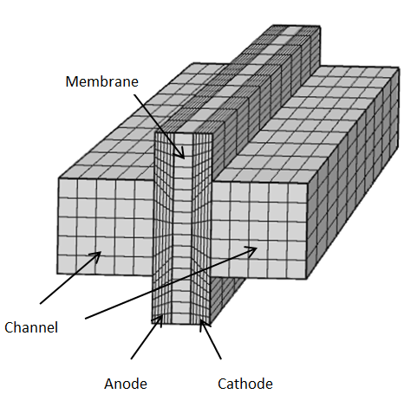

Figure 1: Computational domain of the developed SOFC model

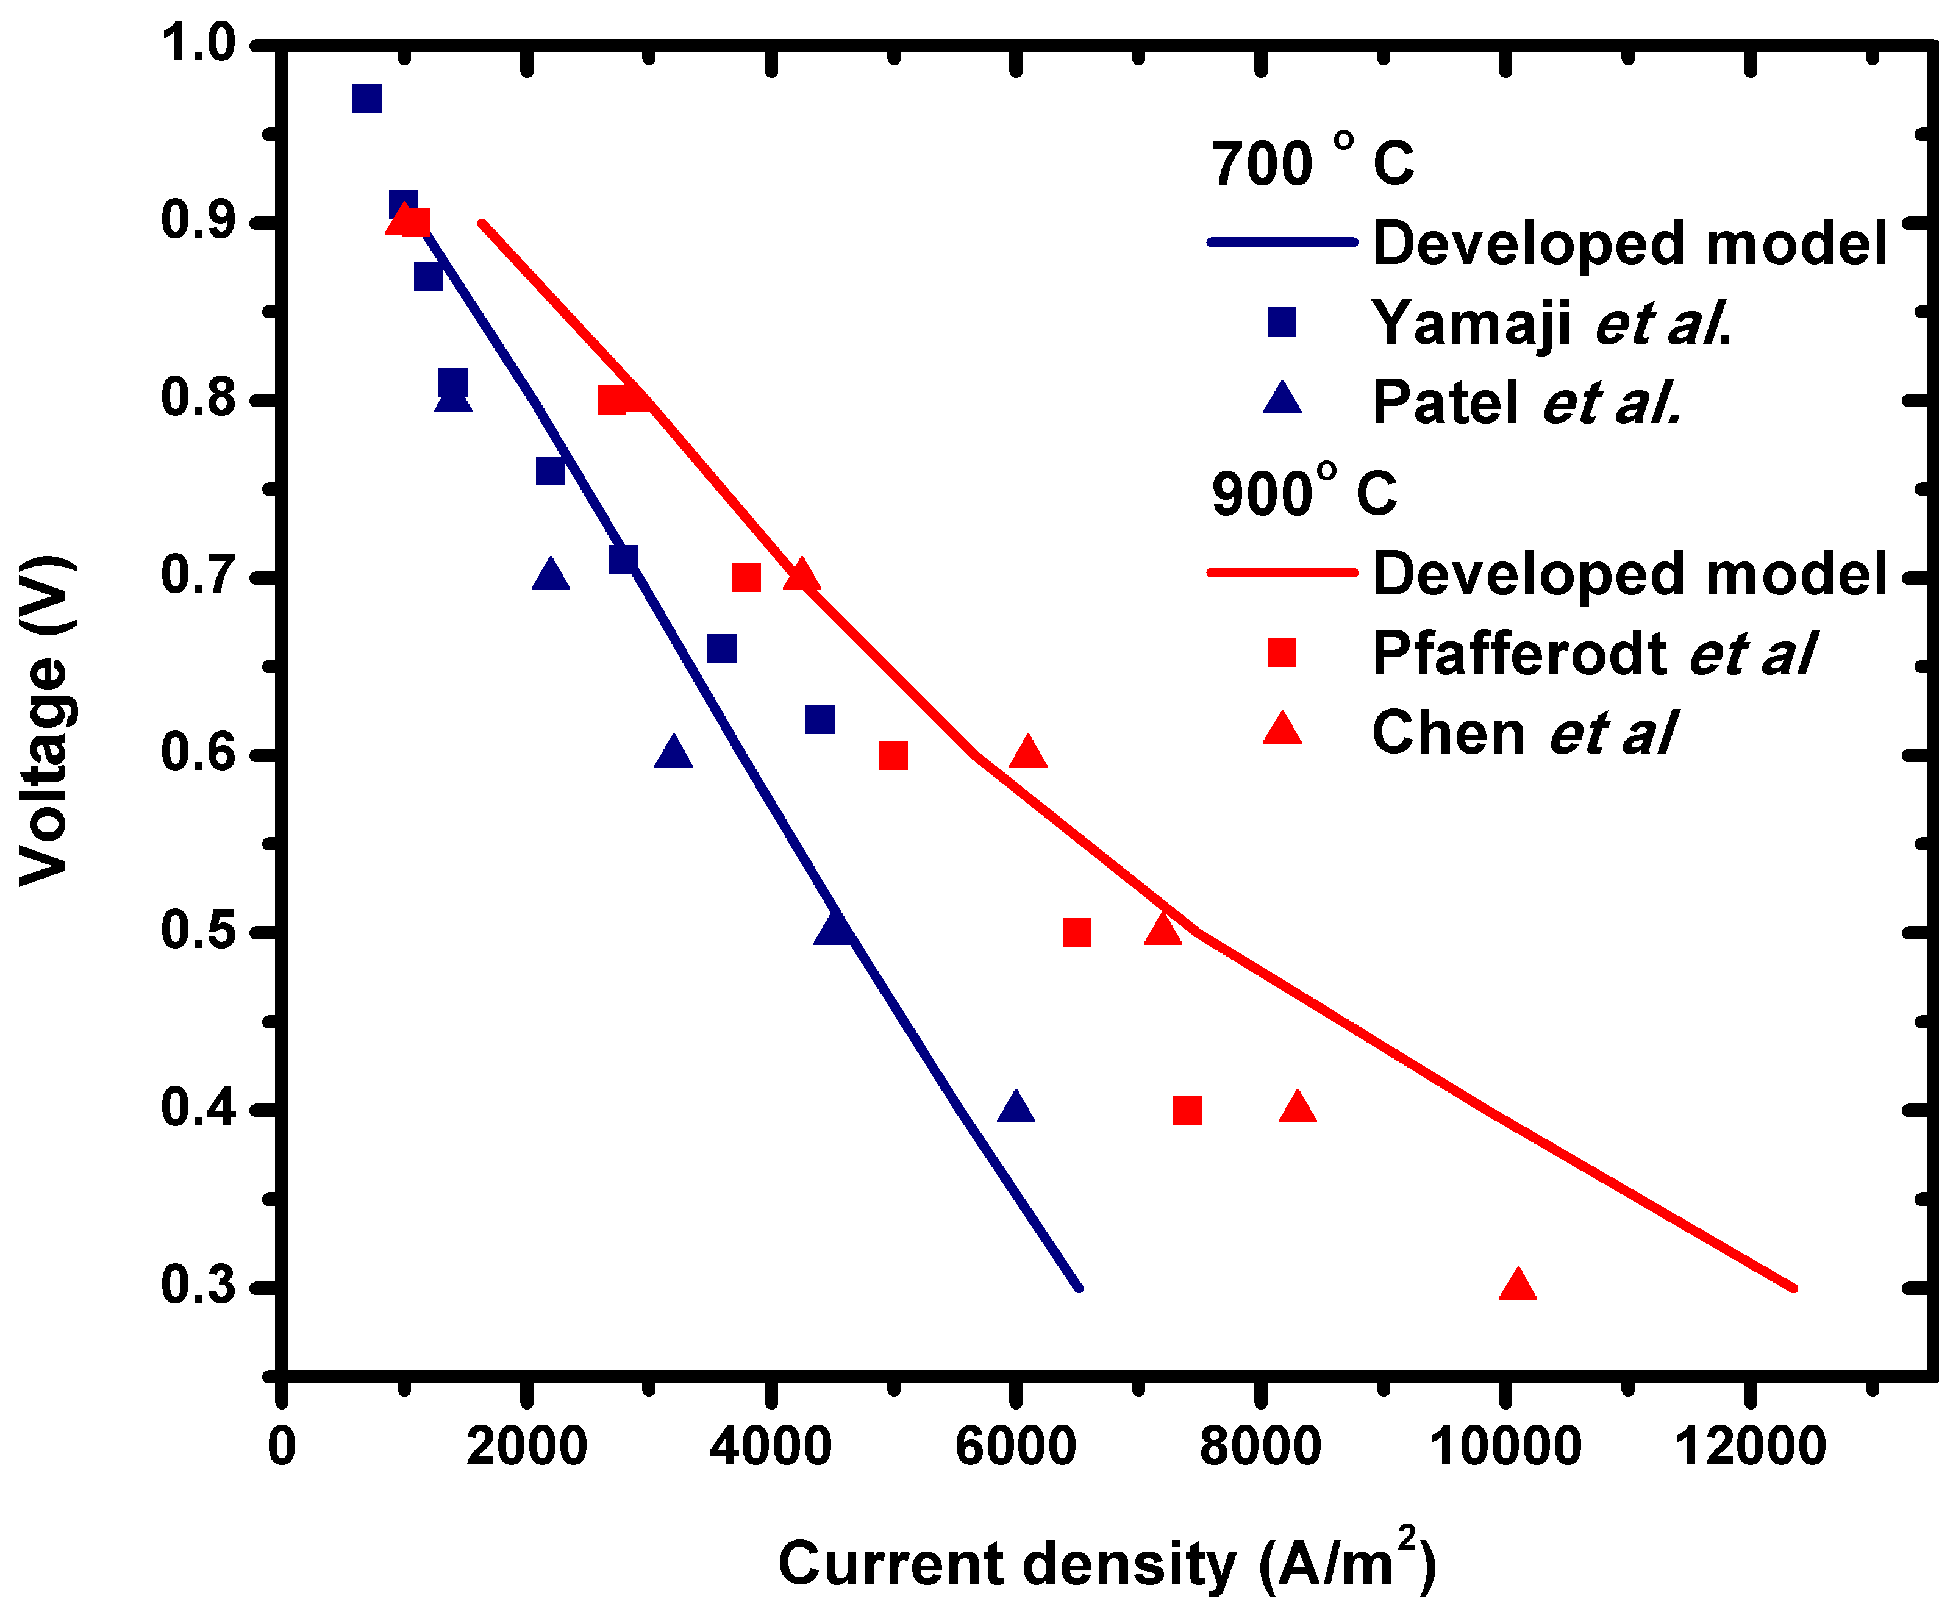

Figure 2: Validation of the developed model at operating temperatures of 700oC and 900oC

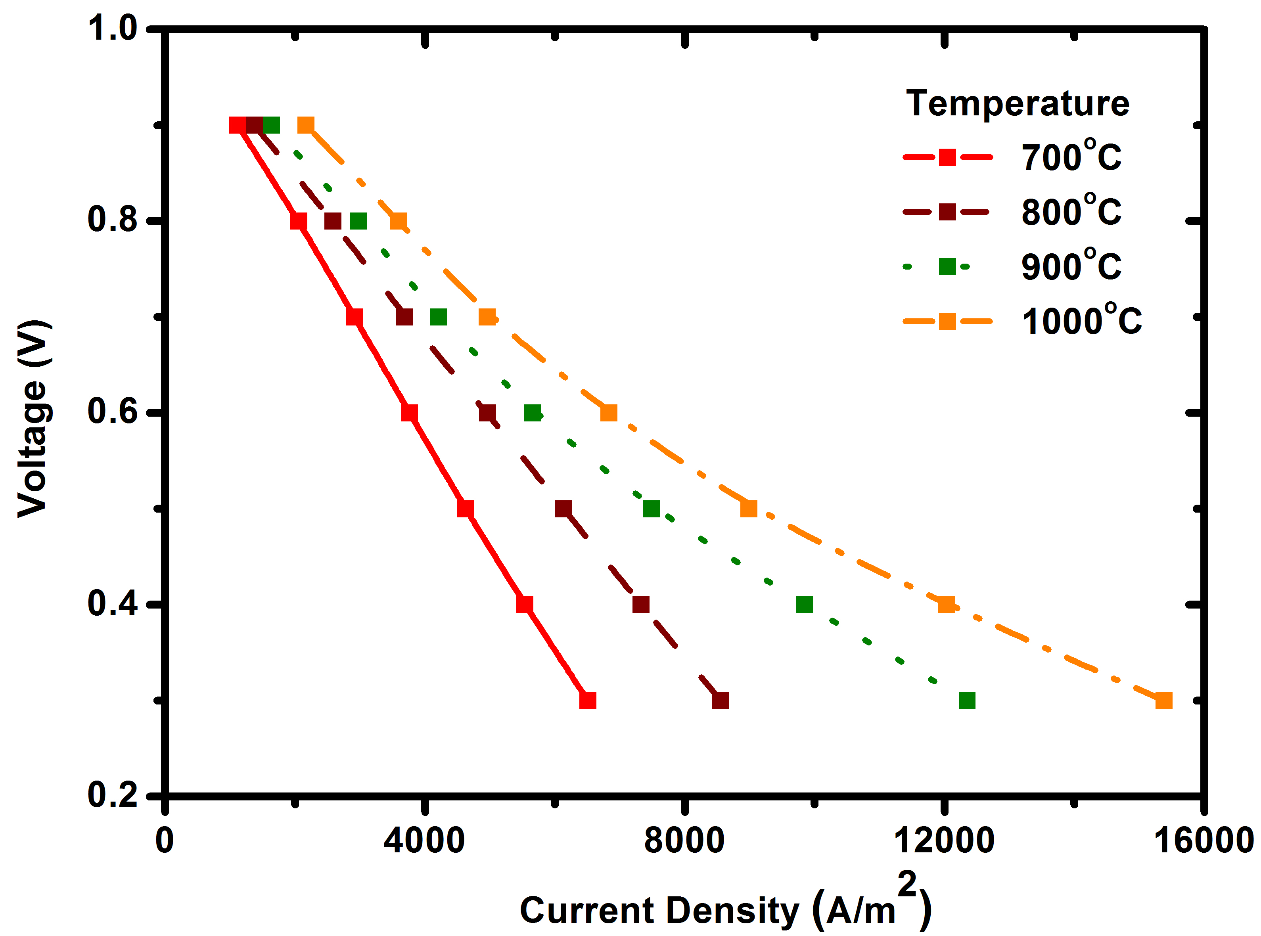

Figure 3: Effect of operating temperatures on the voltage-current (V-I) characteristic of the SOFC

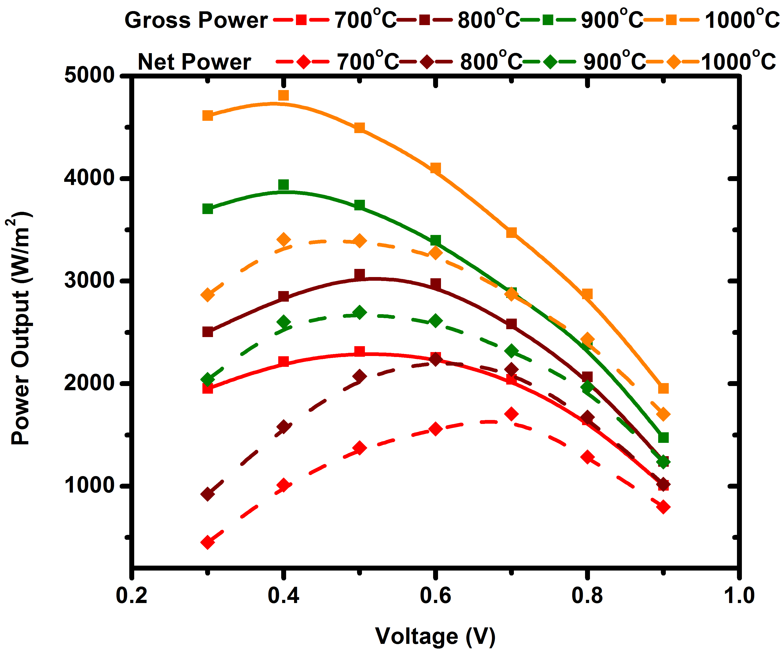

Figure 4: Power output and heater work at different operating temperatures

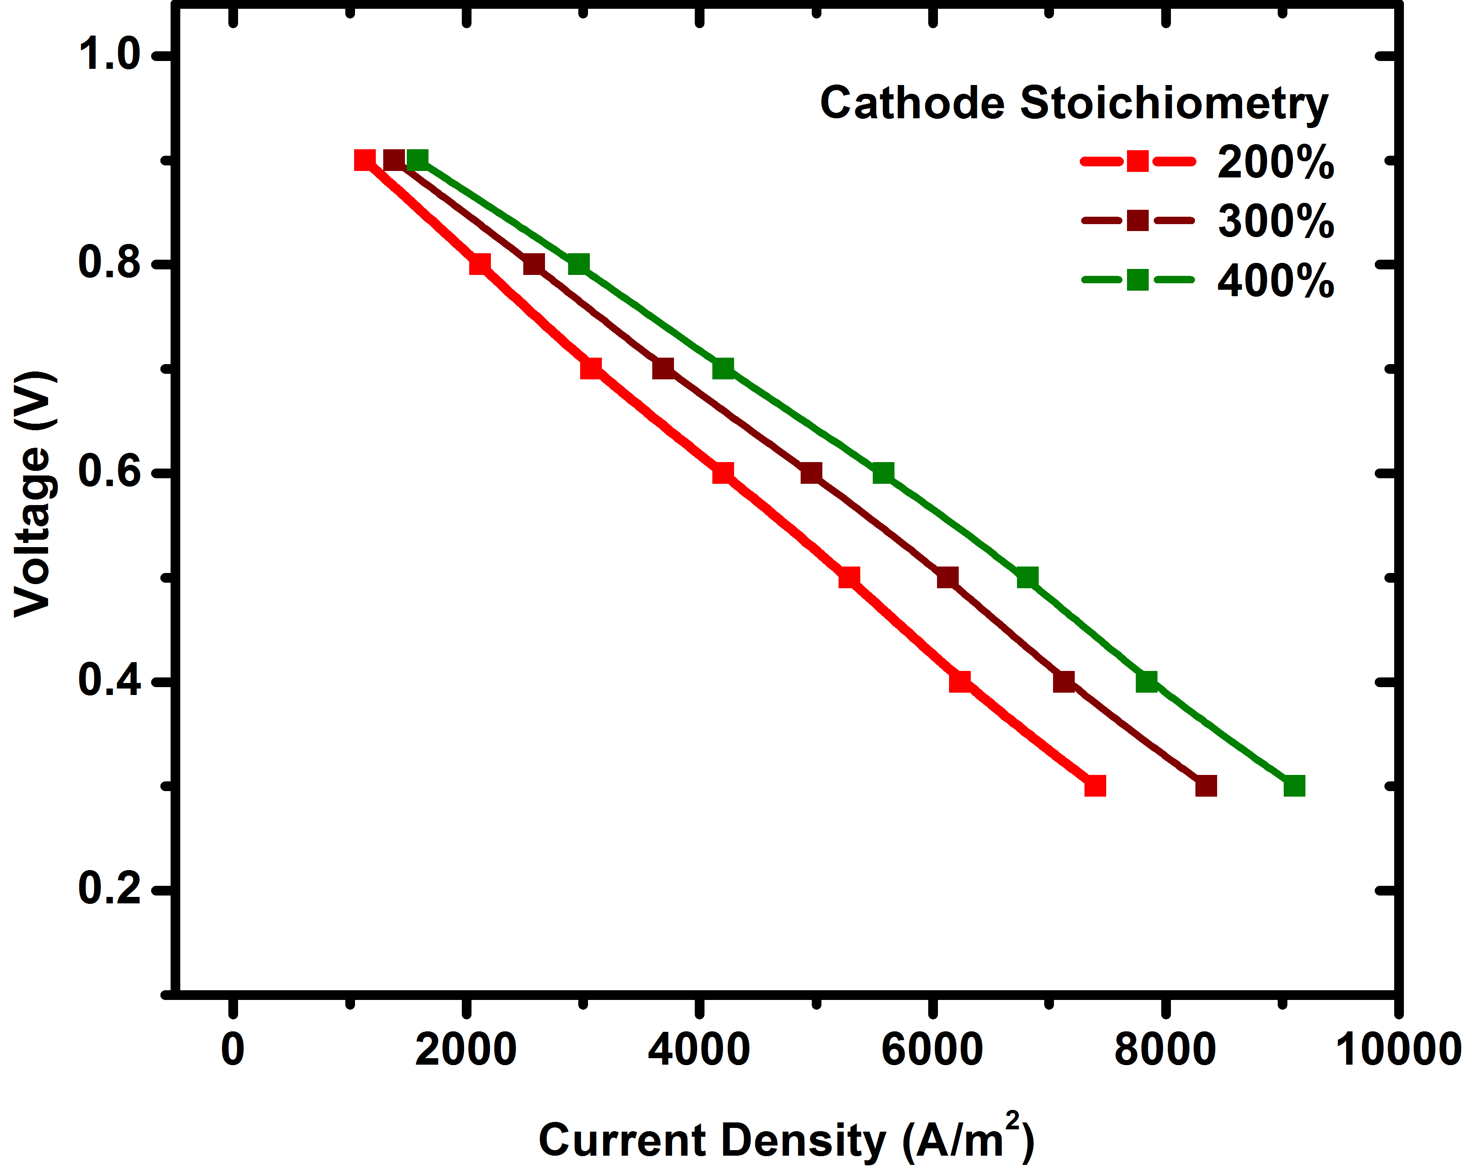

Figure 5: Effect of cathodic stoichiometry on the voltage-current (V-I) characteristic of the SOFC

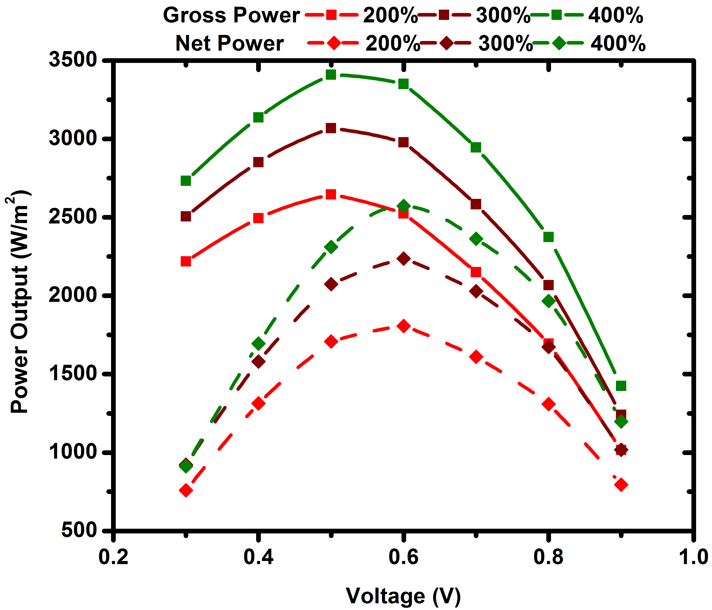

Figure 6: Power output and cathode compressor work at various cathodic stoichiometries

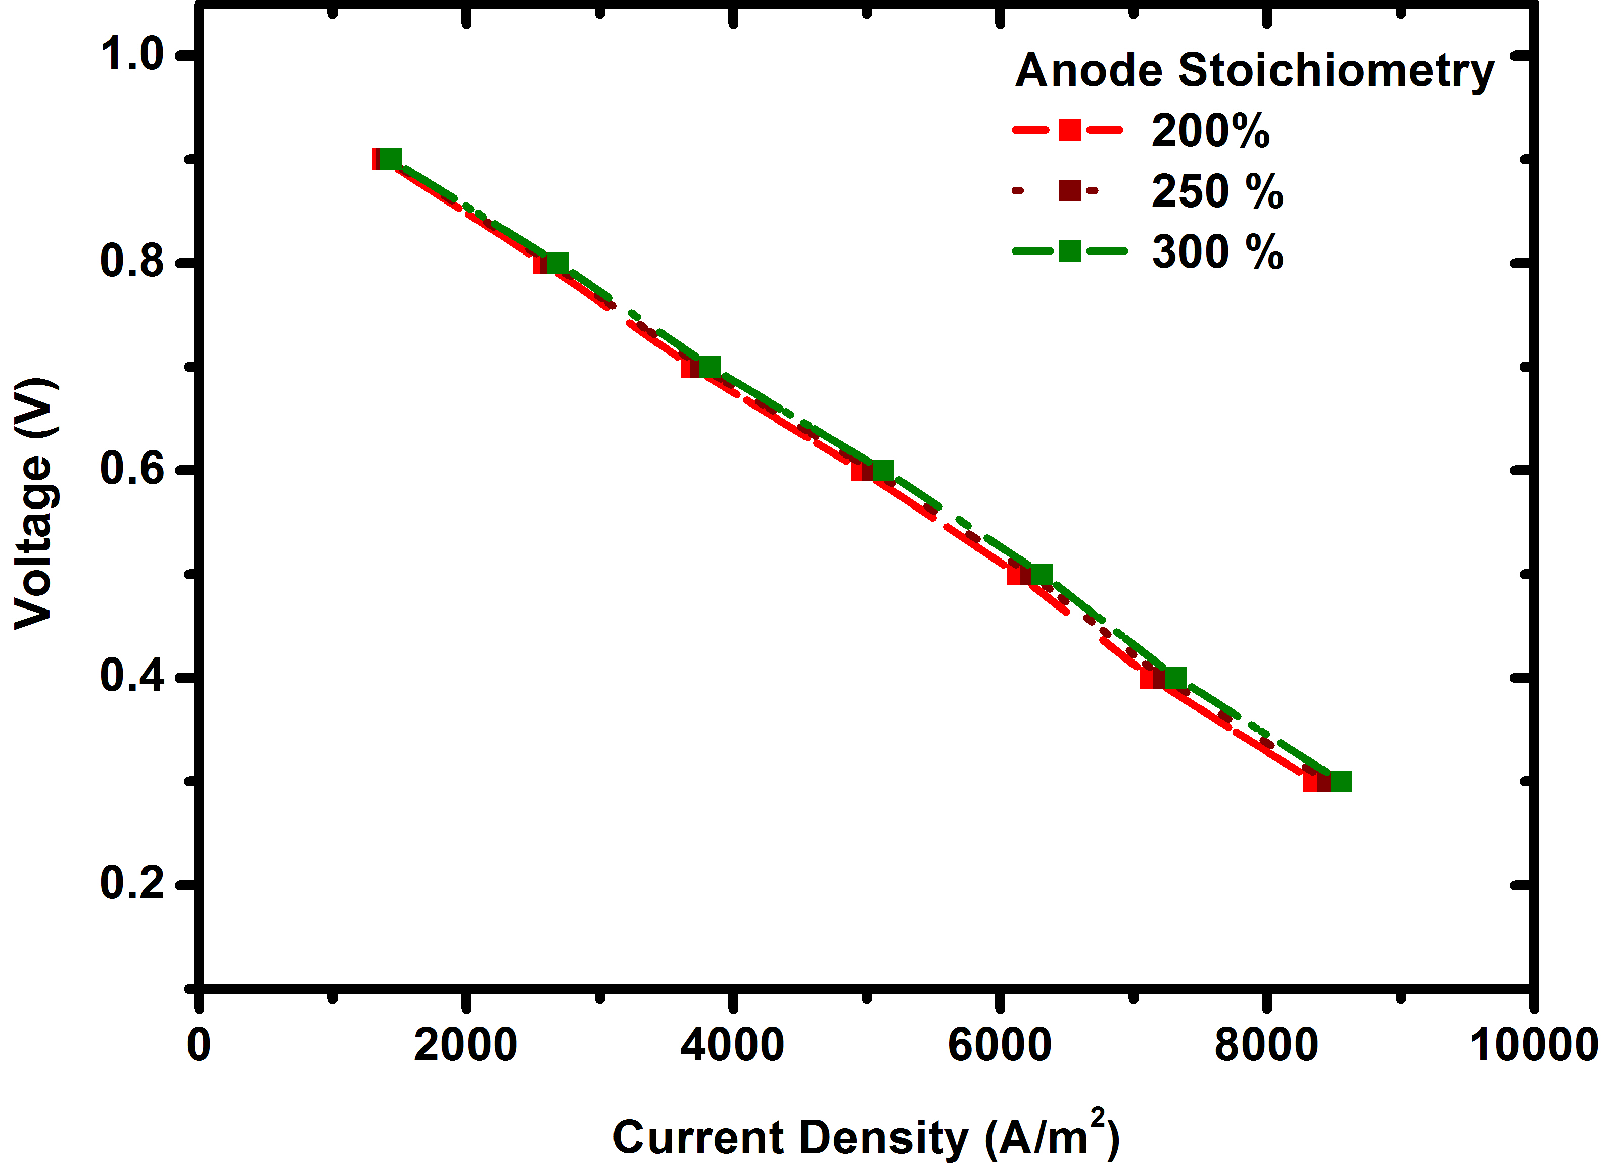

Figure 7: Effect of anodic stoichiometry on the voltage-current (V-I) characteristic of the SOFC

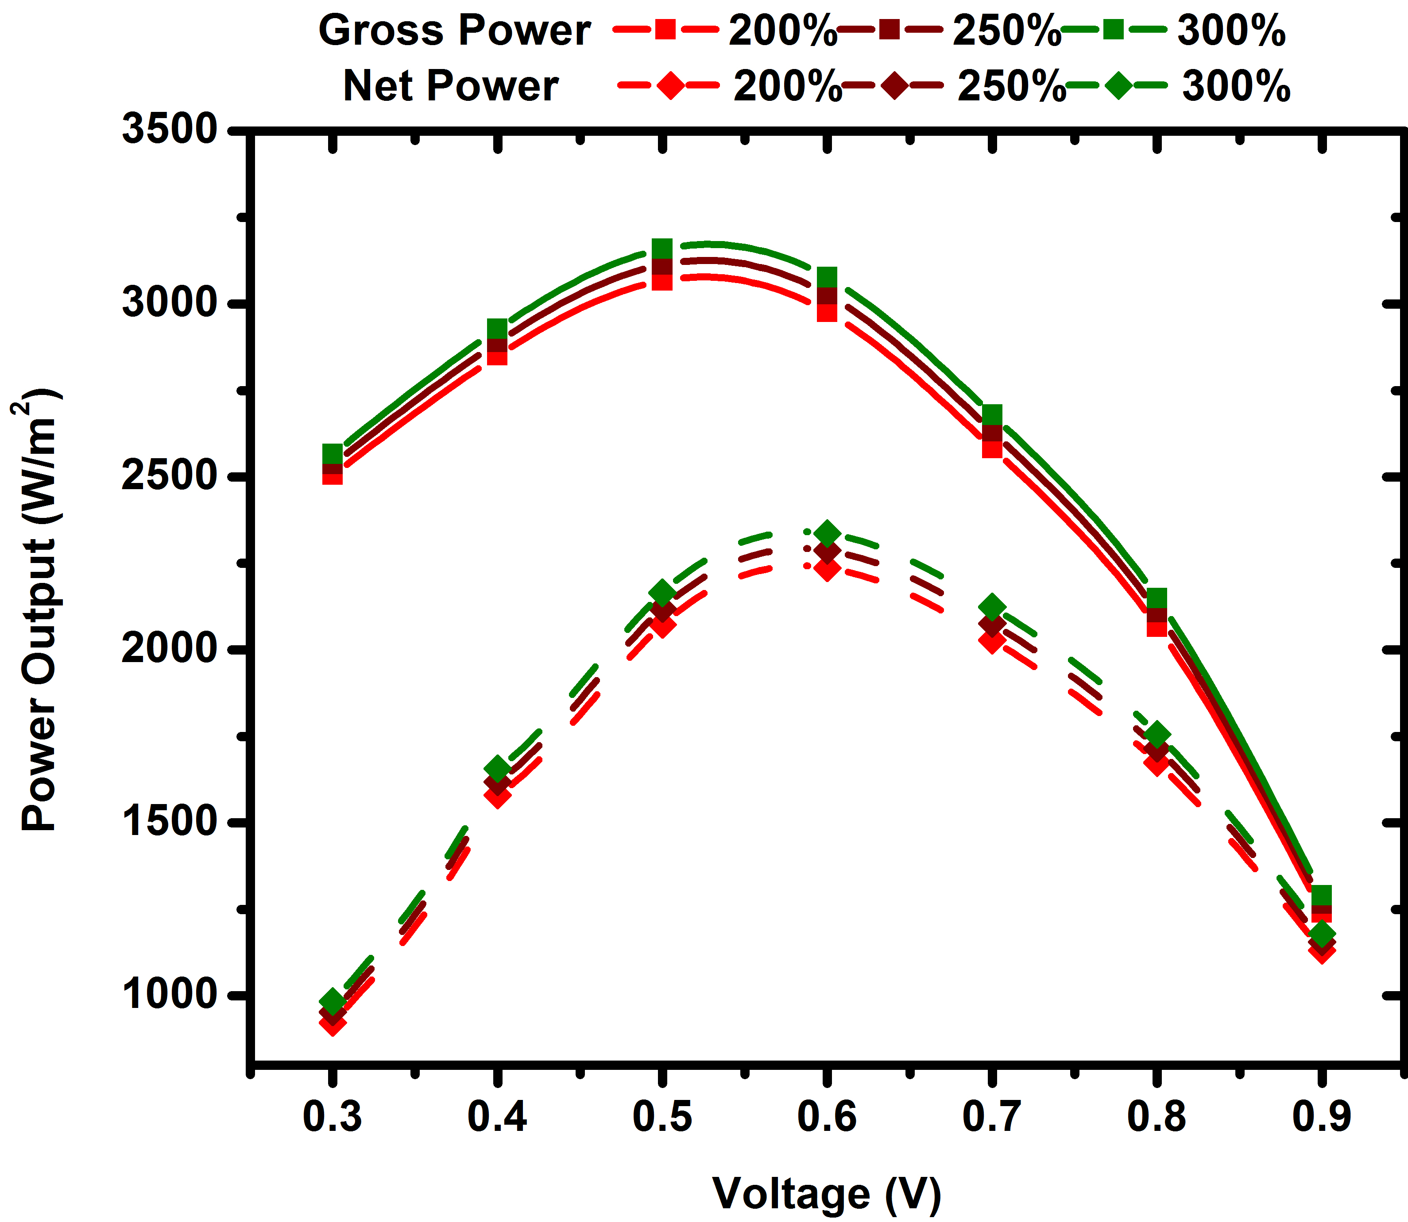

Figure 8: Power output and anode compressor work at various anodic stoichiometries

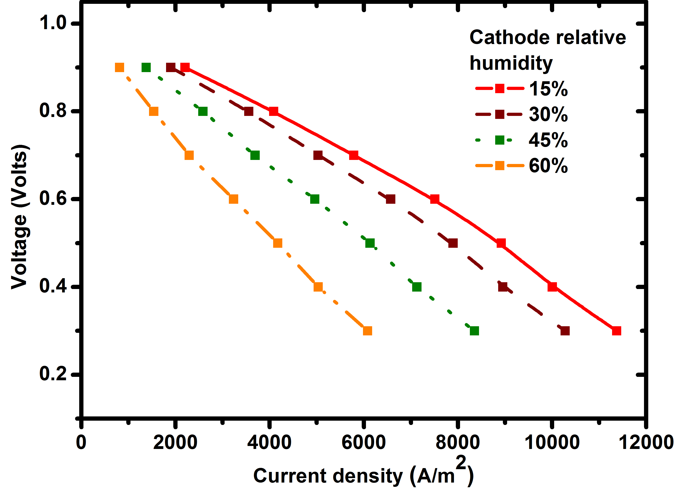

Figure 9: Effect of cathodic relative humidity on the voltage-current (V-I) characteristic of the SOFC

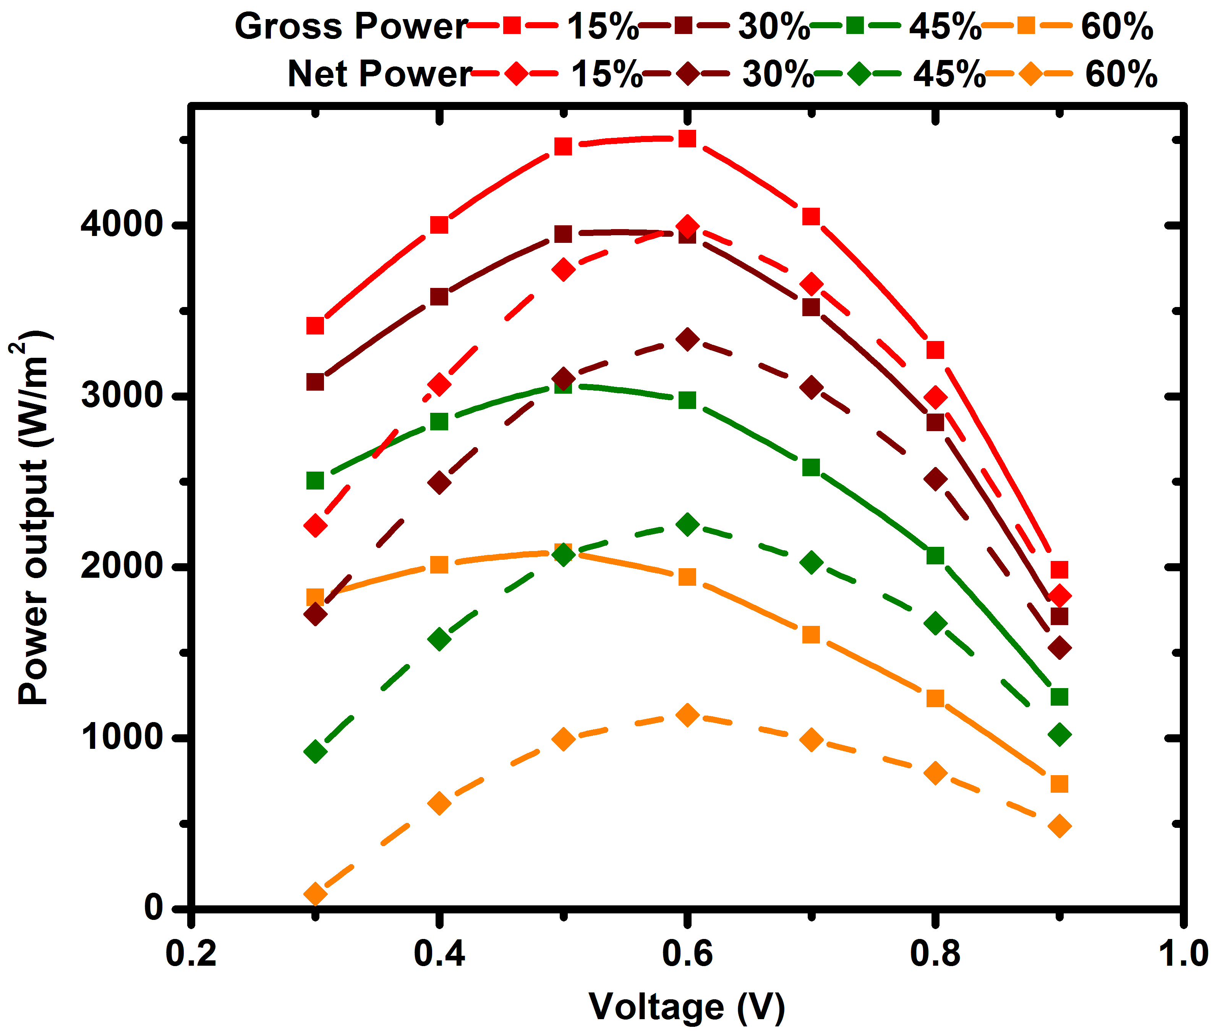

Figure 10: Power output and humidifier work at different cathodic relative humidification levels

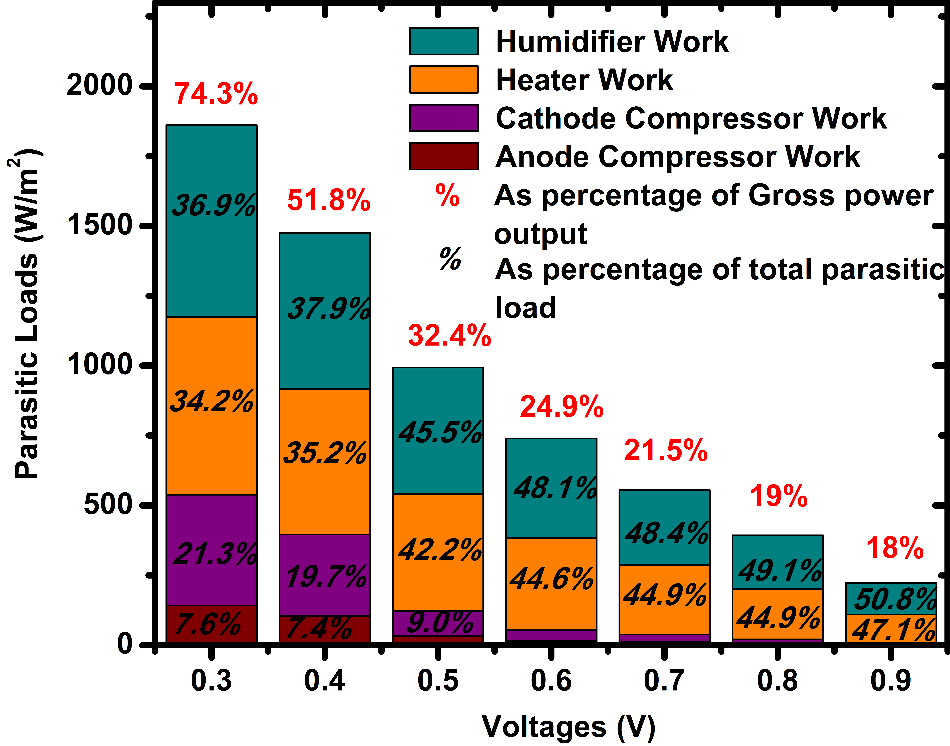

Figure 11: Composition of parasitic loads at various loading conditions (base-case operating conditions)